# Ex No: 1

# Date:

# IMPLEMENT CODE TO RECOGNIZE TOKENS IN C

**AIM:**

To implement the program to identify C keywords, identifiers, operators, end statements like [], {} using C tool.

**ALGORITHM:**

● We identify the basic tokens in c such as keywords, numbers, variables, etc.

● Declare the required header files.

● Get the input from the user as a string and it is passed to a function for processing.

● The functions are written separately for each token and the result is returned in the

form of bool either true or false to the main computation function.

● Functions are issymbol() for checking basic symbols such as () etc , isoperator() to

check for operators like +, -, *, / , isidentifier() to check for variables like a,b,

iskeyword() to check the 32 keywords like while etc., isInteger() to check for numbers

in combinations of 0-9, isnumber() to check for digits and substring().

● Declare a function detecttokens() that is used for string manipulation and iteration

then the result is returned from the functions to the main. If it’s an invalid identifier

error must be printed.

● Declare main function get the input from the user and pass to detecttokens() function.

# PROGRAM:

# #include<stdio.h>

# int main(){

# int count=0,k=0,i=0;

# char a[25];

# printf("Enter expression : ");

# fgets(a,25,stdin);

# while(a[i]!='\0'){

# if(isalpha(a[i])){

# printf("%c - identifier\n",a[i]);

# }

# else if(a[i]=='+' || a[i]=='-'||a[i]=='*'||a[i]=='/'){

# printf("%c - arithmetic operator\n",a[i]);

# }

# else if(a[i]=='='){

# printf("%c - assignment operator\n",a[i]);

# }

# else if(isdigit(a[i])){

# char b[k];

# while(isdigit(a[i])){

# b[k++]=a[i];

# i++;

# }

# printf("%s - digit\n",b);

# k=0;

# i=i-1;

# }

# i++;

# }

# }

**OUTPUT:**

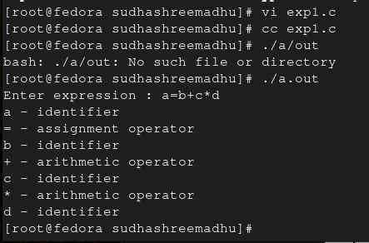

# RESULT: